Procedures

- Hotel Creation: Go to qloapps admin page ->hotel reservation system -> manage hotel. -> Add new / Edit hotel in this page e.g. Bharati Tirtha Kripa
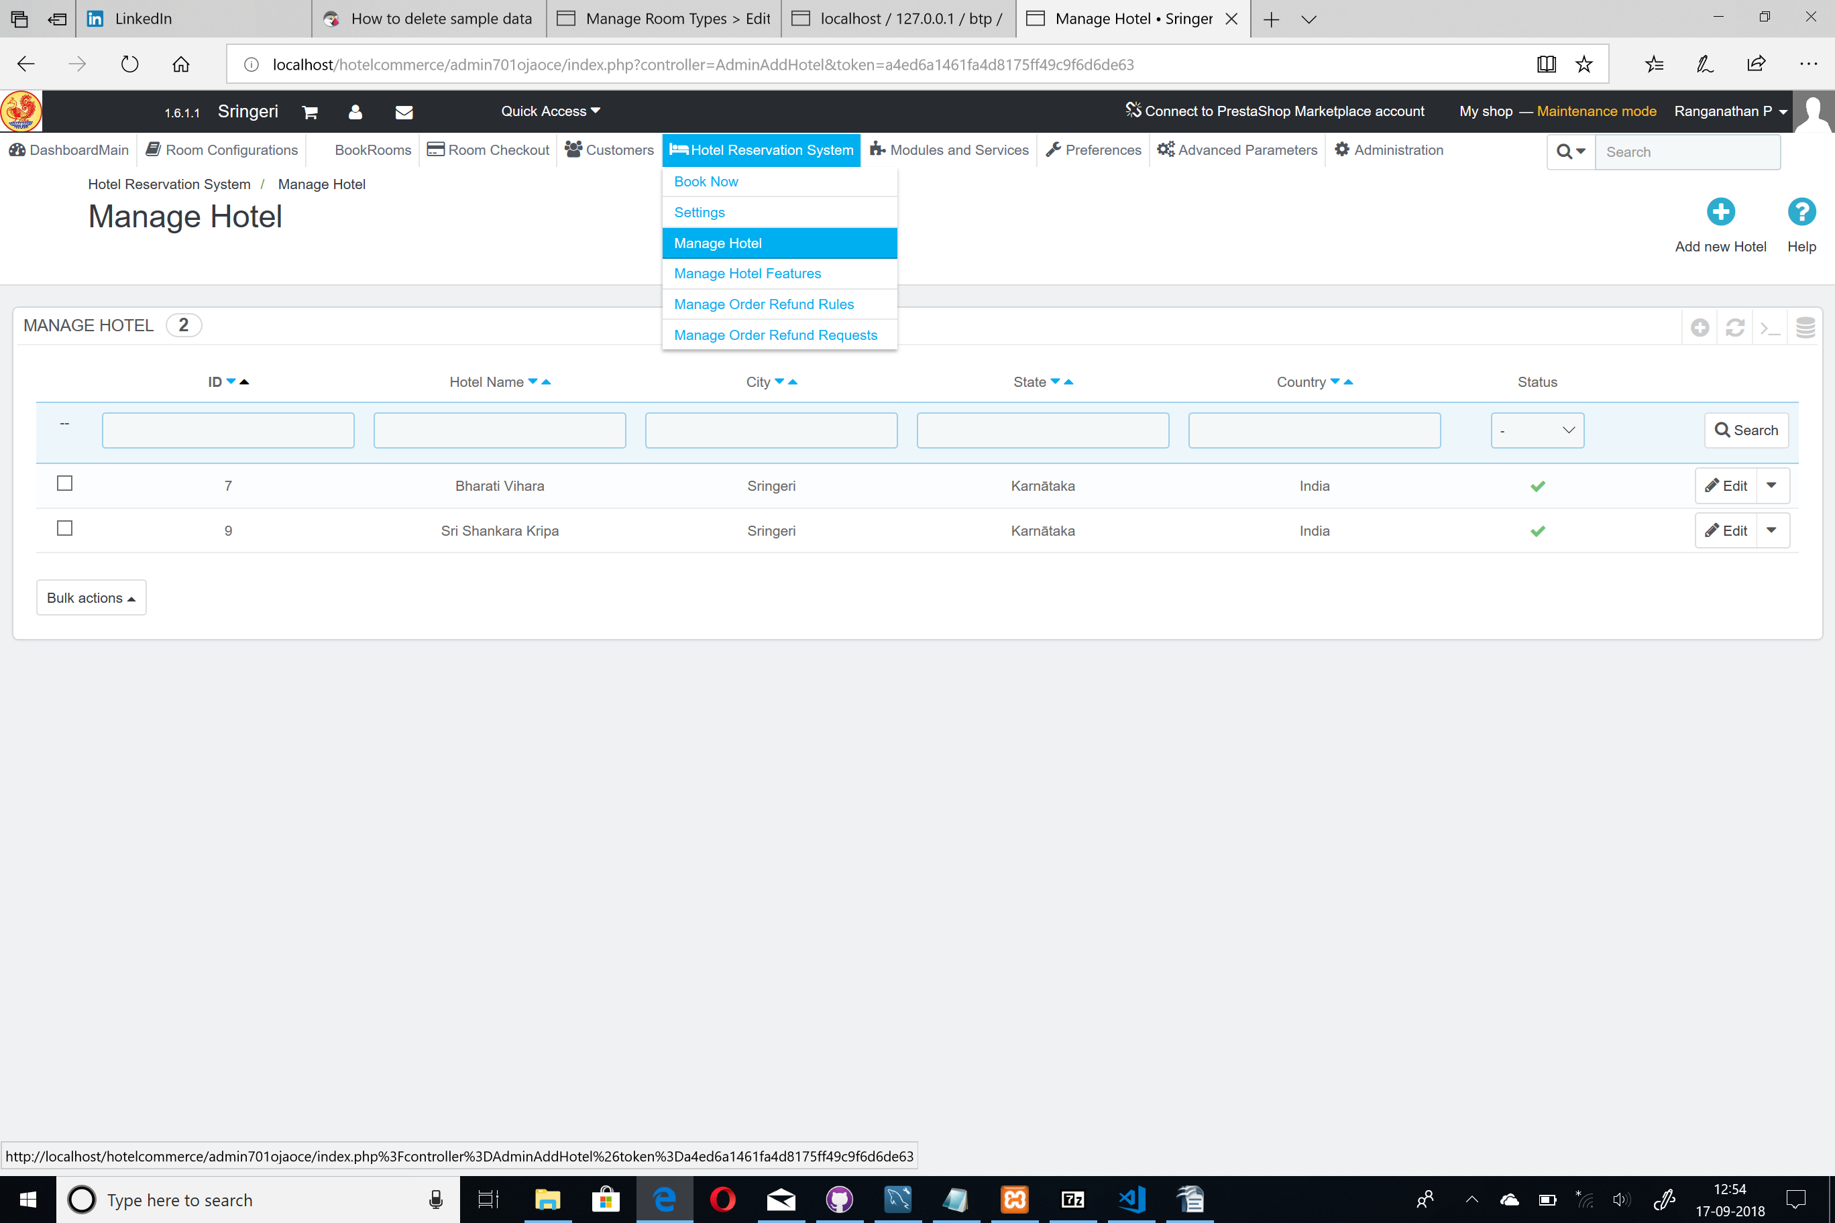
- Basic Category Creation: Create category Sringeri accomodation [only one time]. If this is already existing ignore this step.
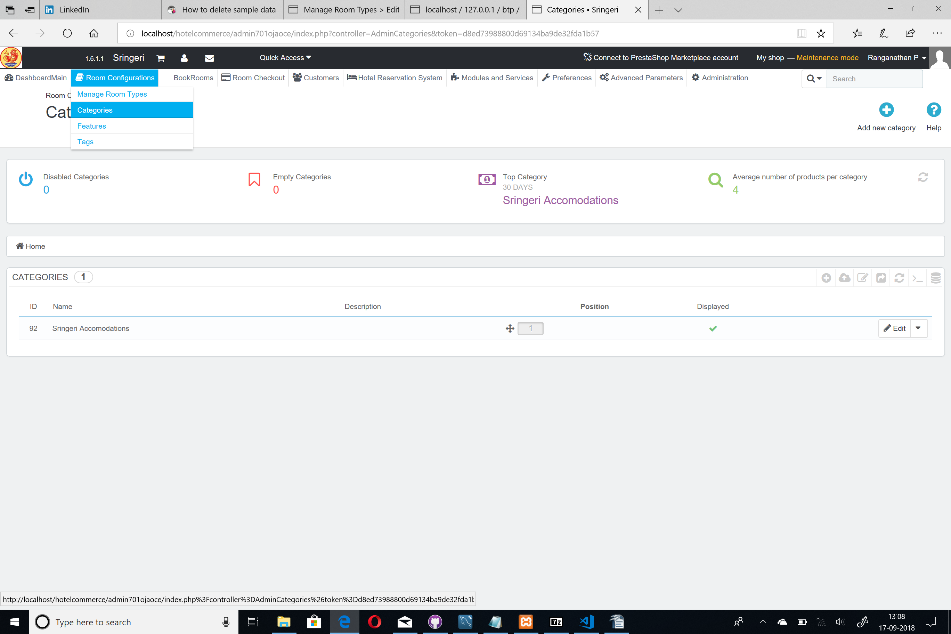
- Basic Room Type Creation and association to category, Hotel: Create Room Type by navigating to Qloapps admin page -> Room Configurations -> Manage Room Types -> Add / Edit

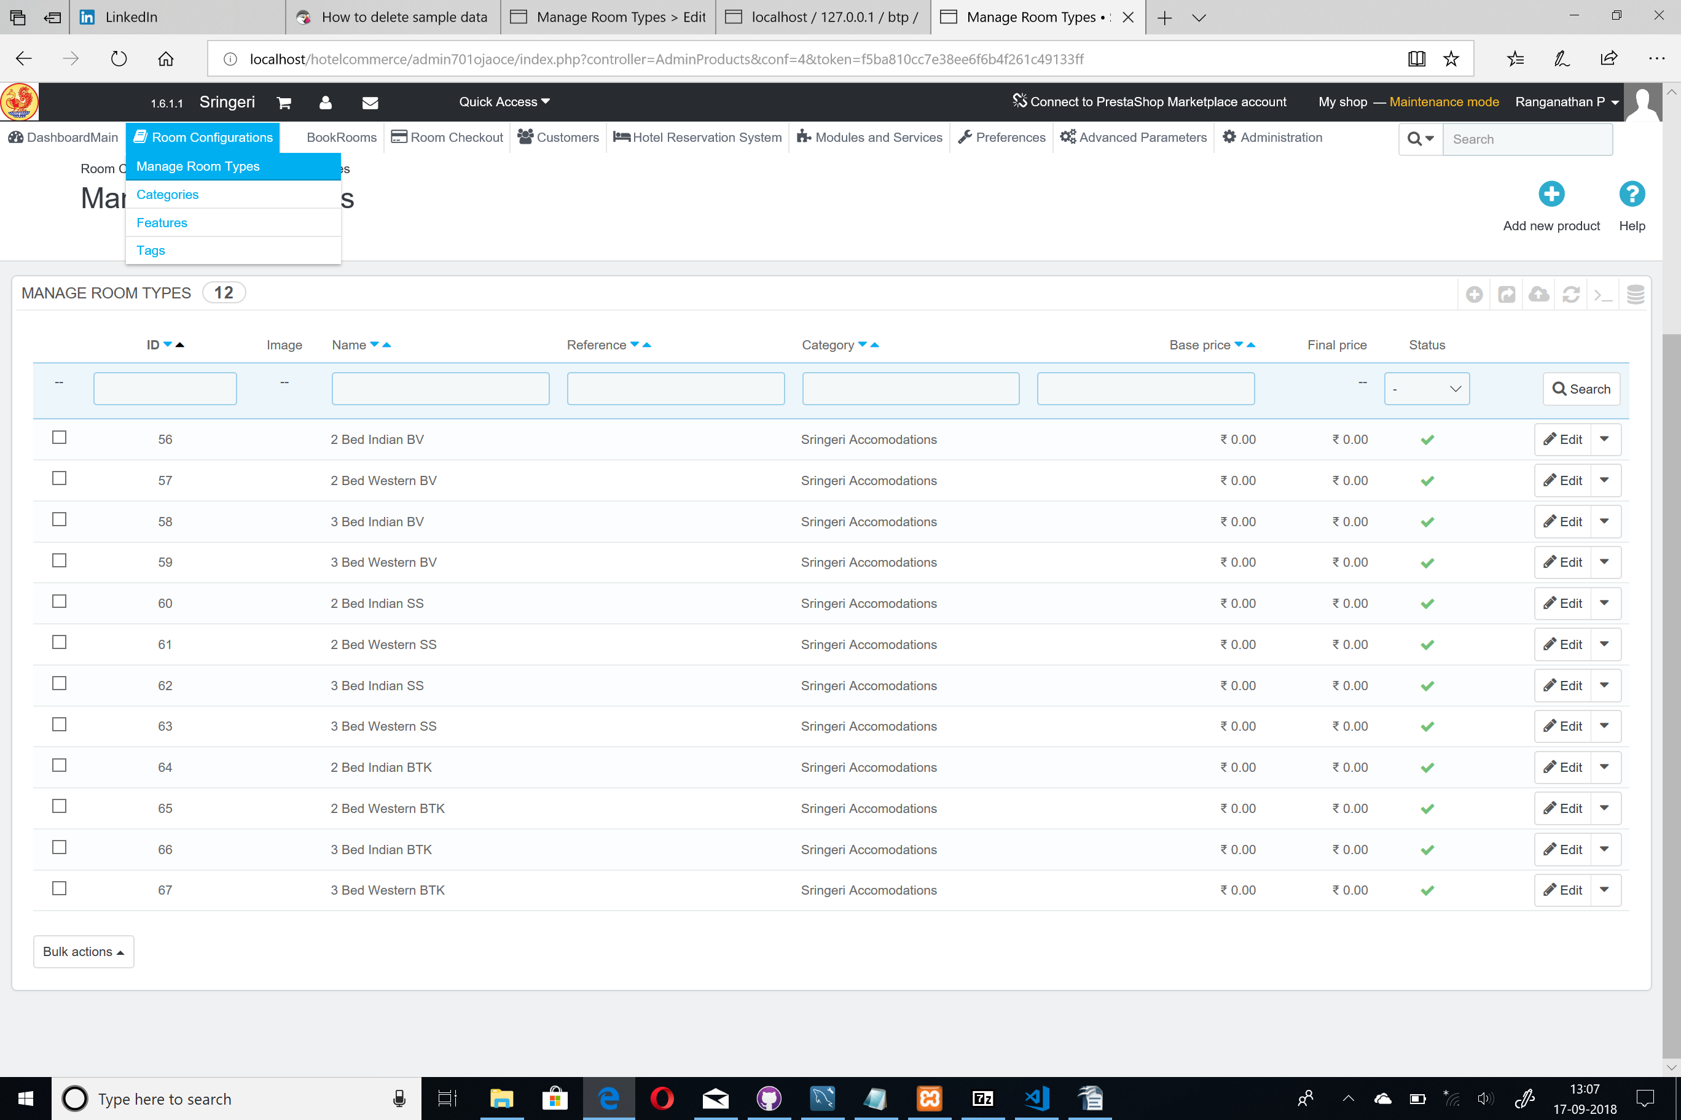

- Import Raw room information from Template into newroomnumbers. Use the custom script to import data for the very first time for room data entry. Do it for the first time. For importing optons based on DB dump this is NOT needed. Import from newroomnumbers into prestoshop. Qloapps tables. This is also NOT needed if you are importing from dB dump SQL

- If using dB dump perform Data Export: Go to phpmyadmin, choose the Database and click on export to export dB with create scehma, drop table option.

- Replicating Data into new instance using the DB import in phpmyadmin

- Password Change for users. Go to phpmyadmin and change pwd in employee table and copying the COOKIE_KEY from settings.inc.php file and choose MD5 function option. Edit the PWD field by adding <COOKIE_KEY><newpwd>
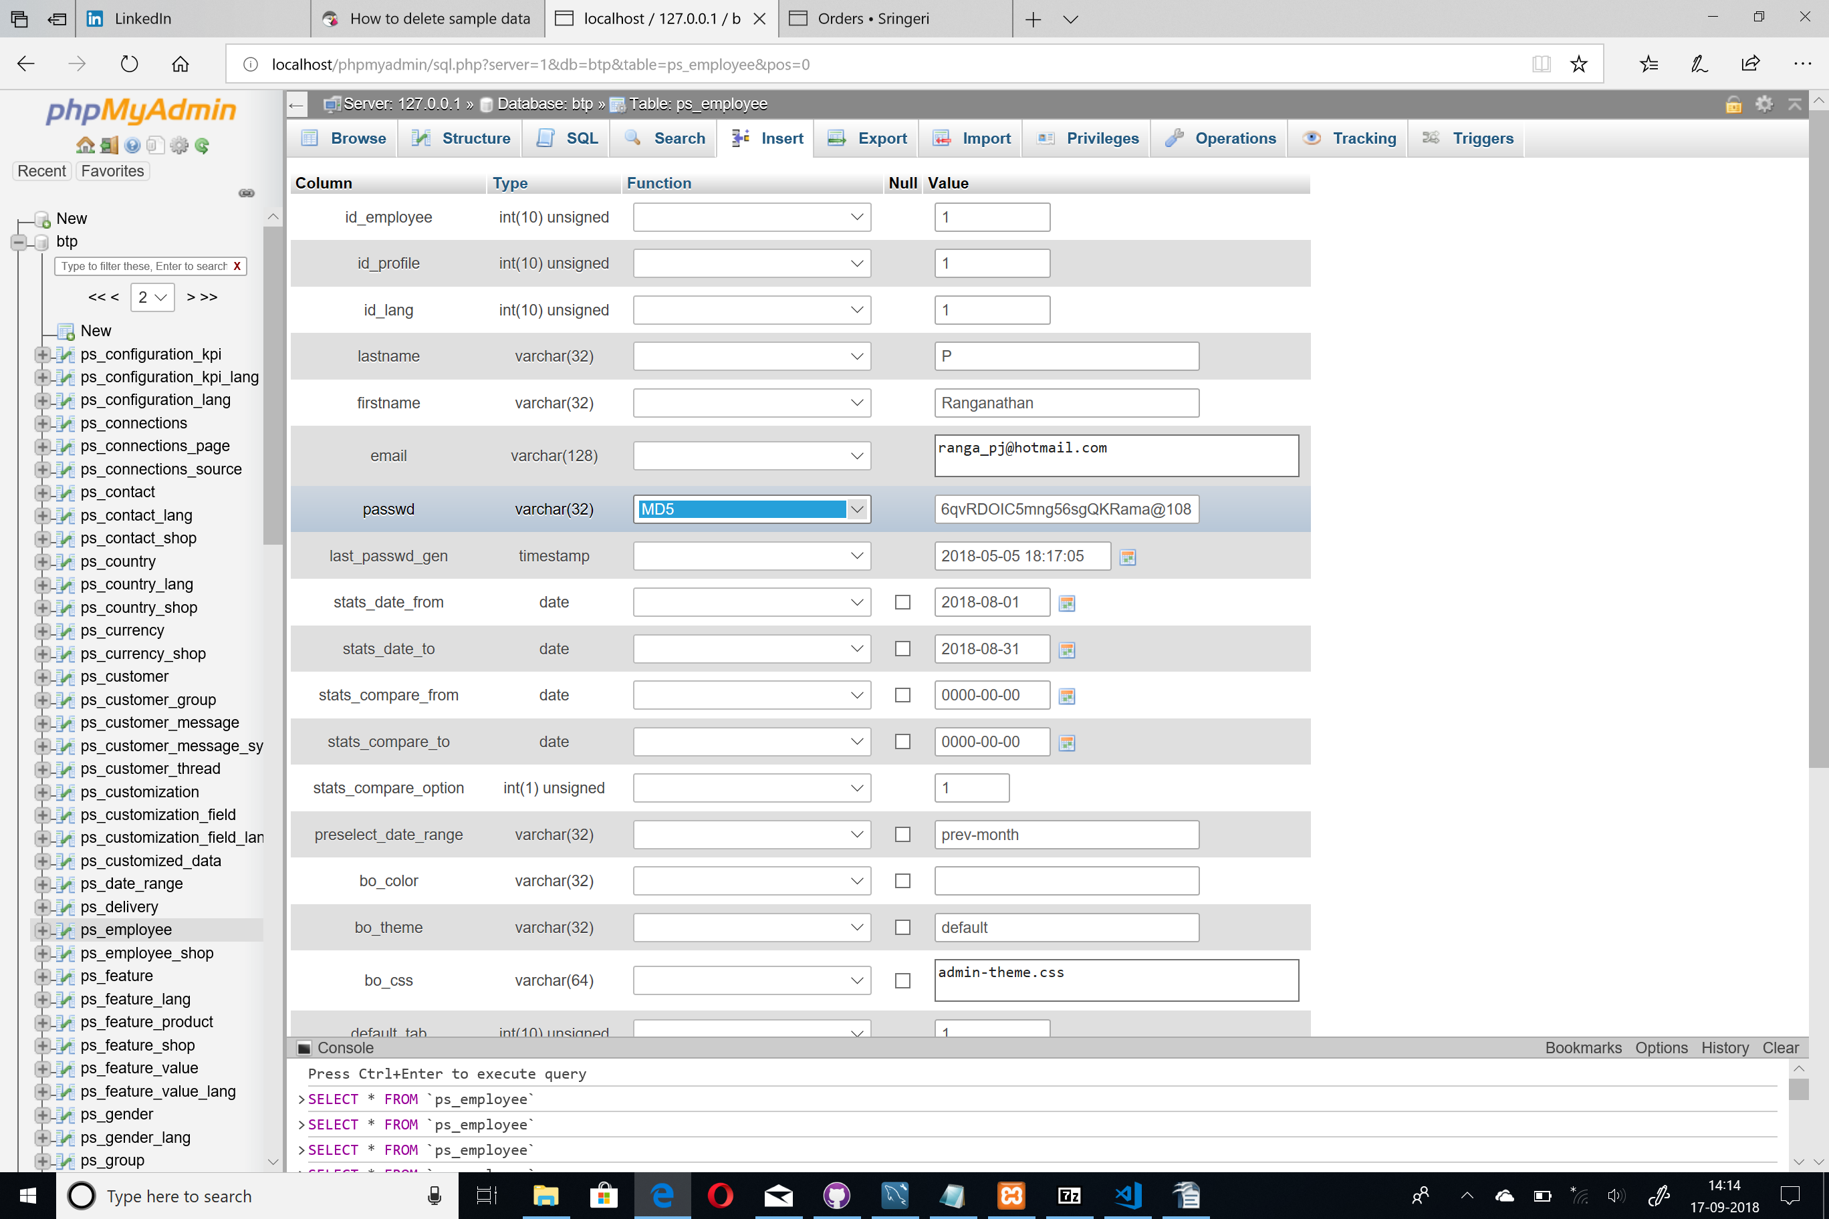
- Re-installing HRS module. Before reinstalling open the hotelreservation.php file and ensure the following lines are commented.

//|| !$htl_helper->insertDefaultHotelEntries()
//|| !$htl_helper->deletePrestashopDefaultCategories()
//|| !$htl_helper->deletePrestashopDefaultFeatures()
//|| !$htl_helper->createHotelRoomDefaultFeatures()
//|| !$htl_helper->insertHotelCommonFeatures()
//|| !$htl_helper->insertHotelRoomsStatus()
//|| !$htl_helper->insertHotelRoomsCategories()
//|| !$htl_helper->insertHotelOrderStatus()
//|| !$htl_helper->insertHotelRoomAllotmentType()
//|| !$htl_helper->createDummyDataForProject()

//|| !$this->deleteTables()

- Login to admin dashboard -> Modules and Services -> Uninstall and install Hotel Booking and Reservation System module.
